Point Placement Guide
Shoulder Analysis (Beta_angle_ana)
As a reminder, this extension enables the computation of shoulder morphological measurements on radiographs (or 2D images) based on precise anatomical landmarks.
The accuracy of the results directly depends on the precision of point placement. Following, you will find a detailed description to help you place the fiducials nodes.

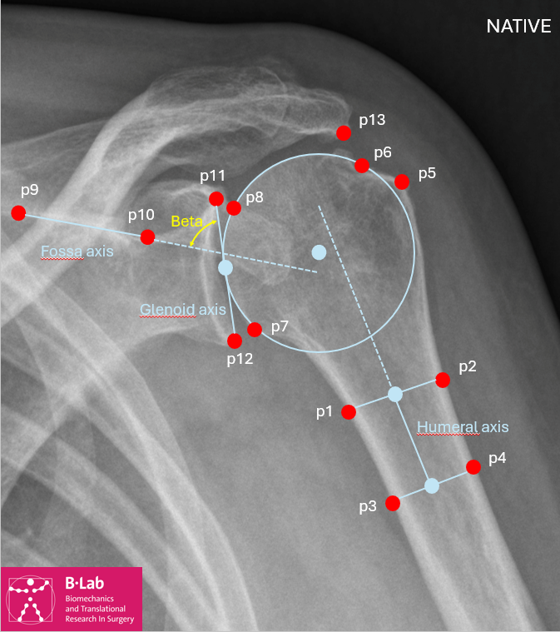
P1, P2 – Diaphysis proximal medial / lateral
Place four points along the ecternal cortical border of the humerus to define the humeral shaft axis, in the following order: proximal medial → proximal lateral → distal medial → distal lateral. P1 marks the proximal medial point and P2 the proximal lateral point.
P3, P4 – Diaphysis distal medial / lateral
Continuing from P1–P2 above, P3 marks the distal medial point and P4 the distal lateral point along the internal cortical border of the humerus, completing the humeral shaft axis.
P5 – GT lateral angle
Place a point at the lateral-most edge of the greater tuberosity.
P6 – Head-GT junction
Place a point on the lateral aspect of the scapular neck at the junction between cartilage and bone, between the glenoid and the scapular body. This point also serves as one of the three contour points used together with P7 and P8 to reconstruct the circle of the humeral head — see note below.
P7 – Head-calcar junction
P8 – Head surface
These points are used, together with P6 above, to reconstruct the circle of the humeral head and estimate the center of rotation. Place P6, P7, and P8 on different locations along the humeral head contour, spacing them as widely as possible.
P9, P10 – Medial fossa / Lateral fossa
Place two points along the cortical margin of the supraspinatus fossa. These points should define a line representative of the scapular axis. This line serves as the scapular reference line.
P11, P12 – Upper glenoid / Lower glenoid
Place the points at the most superior and most inferior aspects of the glenoid rim. These points define the glenoid line.
P13, P14 – Lateral acromion / Medial acromion
Place two points at the lateral and medial edges of the acromion. These points define the acromial line.
P15 – Medial part of the scapular neck
Place a point at the base of the scapular neck on its medial side.

